Project Design Phase-II
Technology Stack (Architecture & Stack)

Date | 26 June 2026
Team ID
Project Name | Leave Approval System
Maximum Marks | 4 Marks

Technical Architecture:
The Deliverable shall include the architectural diagram as below and the information as per the table1 & table 2

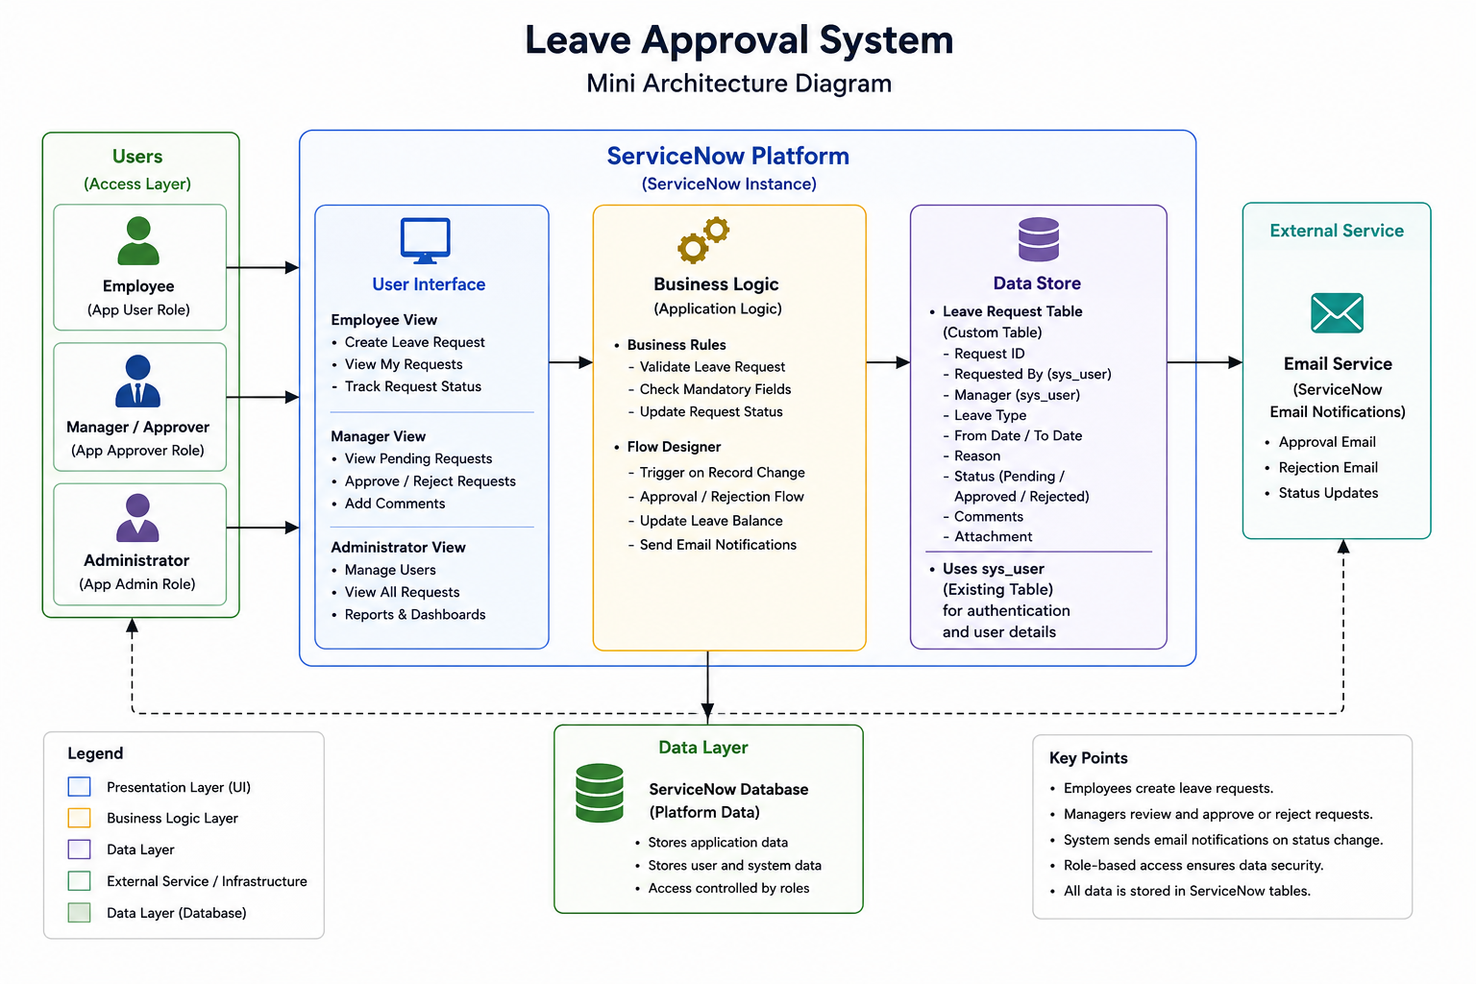

Table 1: Components & Technologies
S.No | Component | Description | Technology
1 | User Interface | Employee, Manager, and Administrator views for leave management | ServiceNow Workspace / Forms / Lists
2 | Application Logic | Leave request creation, validation, approval, and status management | Business Rules, Client Scripts
3 | Workflow Automation | Leave approval workflow, notifications, and record updates | Flow Designer
4 | Database | Stores employee details and leave requests | sys_user, Custom Leave Request table
5 | Email Service | Sends approval and rejection email notifications | ServiceNow Notifications
6 | Security | Role-based access for employees, managers, and administrators | ACLs, Employee Role, Manager Role, Admin Role
7 | Infrastructure | ACLs, Employee Role, Manager Role, Admin Role | ServiceNow Cloud Platform

Table 2: Application Characteristics
Characteristic | Description | Technology
Security | Role-based access ensures employees, managers, and administrators access only authorized data. | ACLs, ServiceNow Roles
Scalability | Supports a growing number of employees and leave requests without major changes. | ServiceNow Platform
Availability | The application is available whenever the ServiceNow instance is operational. | ServiceNow Cloud
Performance | Leave requests, approvals, and notifications are processed efficiently. | Flow Designer, Business Rules
Reliability | Leave records and approval history are stored securely with accurate processing. | ServiceNow Database
Maintainability | Forms, workflows, business rules, and notifications can be updated easily without affecting existing data. | ServiceNow Studio, Flow Designer

